Project 2: Modeling with Systems of Inequalities

Part 1: Determining a Solution to Inequalities
- Is the ordered pair $(5.43,0)$ a solution to all, some, or none of these inequalities? Be prepared to explain your reasoning.
  - $x>0$
  - $y>0$
  - $x≥0$
  - $y≥0$

Part 2: Interpret a Set of Mathematical Models
Here is the nutrition information for some trail mix ingredients: (Note: All values are per 1 gram of ingredient)
Ingredients | Calories (kcal/g) | Protein (g/g) | Sugar (g/g) | Fat (g/g) | Fiber (g/g)
Peanuts | 5.36 | 0.21 | 0.04 | 0.46 | 0.07
Almonds | 5.71 | 0.18 | 0.21 | 0.46 | 0.07
Raisins | 3.00 | 0.03 | 0.60 | 0.00 | 0.05
Chocolate pieces | 4.76 | 0.05 | 0.67 | 0.19 | 0.02
Shredded Coconut | 6.67 | 0.07 | 0.07 | 0.67 | 0.13
Sunflower Seeds | 5.50 | 0.20 | 0.03 | 0.47 | 0.10
Dried Cherries | 3.25 | 0.03 | 0.68 | 0.00 | 0.03
Walnuts | 6.43 | 0.14 | 0.04 | 0.61 | 0.07
Tyler and Jada each designed their own custom trail mix using two of these ingredients. They wrote inequalities and created graphs to represent their constraints.
Tyler’s Trail Mix | Jada’s Trail Mix
- $x+y>50$  - $4.76x+6.67y≤400$  - $0.67x+0.07y<30$  - $x>0$  - $y>0$ | - $w+z>50$  - $0.14w+0.03z>4$  - $0.61w+0z≤15$  - $w>0$  - $z>0$
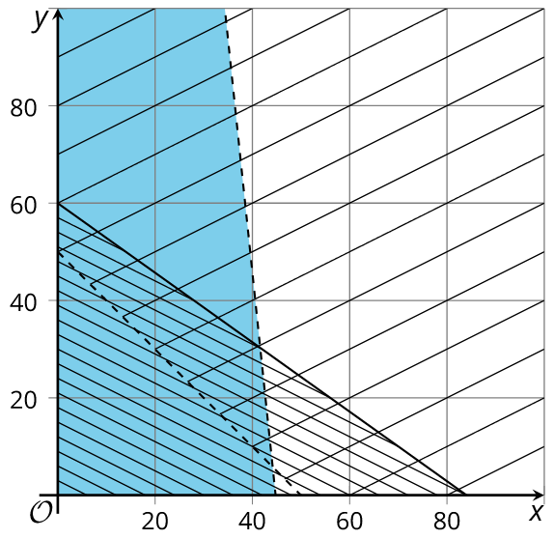 | 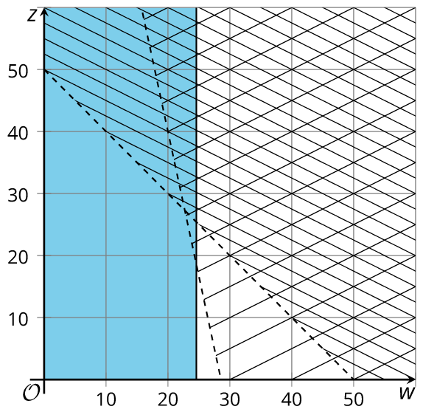

Use the inequalities and graphs to answer these questions about each student's trail mix. Be prepared to explain your reasoning.
- Which two ingredients did they choose?
- What do their variables represent?
- What does each constraint mean?
- Which graph represents which constraint?
- Name one possible combination of ingredients for their trail mix.

Part 3: Perform Mathematical Modeling
It’s time to design your own trail mix!
- Choose two ingredients that you like to eat. (You can choose from the ingredients in the previous activity, or you can look up nutrition information for other ingredients.)
- Think about the constraints for your trail mix. What do you want to be true about its calories, protein, sugar, fat, or fiber?
- Write inequalities to represent your constraints. Then, graph the inequalities.

- Think about the constraints for your trail mix. What do you want to be true about its calories, protein, sugar, fat, or fiber?
- Write inequalities to represent your constraints. Then, graph the inequalities.
Pause here so your teacher can review your work and give further instructions for displaying your work

